
PB1/CSQP/1222/A 08-DEC-2022
PRE-BOARD EXAMINATION – I (2022-2023)
Subject: Computer Science  Grade: XII |  | Max. Marks: 70  Time: 3 hours
General Instructions:
1. This question paper contains five sections – A , B , C , D and E. Each section is compulsory.
2. Section A has 18 questions of 1 mark each.
3. Section B contains 7 very short answer type questions of 2 mark each.
4. Section C contains 5 short answer type questions of 3 mark each.
5. Section D has 3 long answer type questions of 5 mark each.
6. Section E has 2 questions carrying 4 marks each. One internal choice is given in Q35 against part c.
7. All programming questions to be answered using Python Programming language only.
8. This Question paper has 11 pages.
 | SECTION A
1 | State True or False:-  “Any parameter cannot have a default value unless all parameters appearing on its right have their default values.” |  | 1
2 | A __________ is a Python collection which is ordered, changeable and do not allow duplicates. |  | 1
3 | Observe the dictionaries given below and answer the question given below:-  car = {"brand": "Ford", "model": "Mustang", "year": 1964}  newcar= {"noofkms": 10000 , "County": "US" , "brand":"Edge"}  Which statement will add the contents of dictionary newcar to dictionary car.  - car.add(newcar)  - car.insert(newcar)  - newcar.update(car)  - car.update(newcar) |  | 1
4 | Consider the given expression:  True or True and not False or True and not True  Which of the following will be correct output if the given expression is evaluated?  - True  - False  - NONE  - NULL |  | 1
5 | Select the correct output of the code:  a = "EEPROM"  a = a.lstrip('E')  b = a[0] + "%" + str(len(a)) + "%" + a[3] + "%"  print(b)  - P%4%M%  - E%6%R%  - E%5%O%  - P%4%O% |  | 1
6 | Madhav wants to open an already created file “Story.txt” for searching some information. In which mode should Madhav open the file to perform the task.  - w  - r  - a  - r+ |  | 1
7 | Fill in the blanks:  _________ command is used to group the result set by one or more columns.  - Group by  - Order by  - Select  - Having |  | 1
8 | Which SQL command is used to add a new row in an already existing table.  - UPDATE  - INSERT  - ALTER  - ADD |  | 1
9 | Which of the following statement(s) would give an error after executing the following code:  X=”EXAMINATION” # Statement 1  Y= (“A”,”B”,”C”) # Statement 2  Z= X+Y # Statement 3  print(X[5]+Y[1]) # Statement 4  X[2]+=2 # Statement 5  - Statement 3 and 5  - Statement 4 and 5  - Statement 5  - Statement 3, 4 and 5 |  | 1
10 | Fill in the blank:  Foreign key values are derived from the ___________ of some other table.  - Candidate key  - Primary key  - Alternate key  - Foreign key |  | 1
11 | Assume f is the file object .The syntax of tell() is  - X=f.tell()  - X=pickle.tell(f)  - X=f.tell(position)  - X=pickle.tell(position) |  | 1
12 | ______ keyword is used to get the total no of rows in a relation.  - ALL  - COUNT(*)  - SUM()  - DISTINCT |  | 1
13 | ______ is a chat protocol  - STMP  - POP  - FTP  - IRC |  | 1
14 | What will the following expression be evaluated to in Python:  print(54/3+(3%12/2)*2)  - 21  - 21.0  - 18.0  - 18 |  | 1
15 | Which SQL keyword is used in SELECT statement to check for the presence of wild card characters  - IN  - WITH  - LIKE  - WHERE |  | 1
16 | Which statement is used to give the count of the no of records satisfying the SQL command.  - fetchall()  - fetchone()  - fetchmany(all)  - rowcount |  | 1
17 | Assertion(A) – Positional arguments need to be included in the proper position or order.  Reasoning(R) - The first positional argument always needs to be listed first when the function is called.  - Both A and B are true and R is the correct explanation for A  - Both A and B are true and R is not the correct explanation for A  - A is true but R is false  - A is false but R is true |  | 1
18 | Assertion(A) – Binary file is a file whose content is in a binary format consisting of a series of sequential bytes, each of which is eight bits in length.  Reasoning(R) – Character translations take place in a binary file.  - Both A and B are true and R is the correct explanation for A  - Both A and B are true and R is not the correct explanation for A  - A is true but R is false  - A is false but R is true |  | 1
 | SECTION B
19 | Suhasini has written a Python code. Her code is having errors. Rewrite the correct code and underline the corrections made.  def stroper(st)  x=st[2]+12  st[3]=x  printf("New string is" , st)  stroper("2022") |  | 2
20 | Explain Packet Switching  OR  State any 2 advantages of using fiber optic wired transmission media. |  | 2
21 | - Given the Python string declaration:  Msg="DATAMINING-YEAR2022"  Write the output of : print(Msg[-4:10:-2])  - Write the output of the following code given below:  x = [12,67,'A',4]  d = ('W','6',7,2,'A')  x.append(x[2]+d[1])  x.append(x[3]+d[2])  print(x) |  | 2
22 | Differentiate between primary key and candidate key. State examples. |  | 2
23 | - Write the full forms of the following:-  - TCP/IP ii) HTTP  - State the function of Telnet |  | 2
24 | Predict the output of the Python code given below:-  def func(p,q=5):  p=p*q  q=p//q  print(p,"$",q)  return p  a=(12,8)  for i in a:  a=func(i)  b=func(i,a)  print(a,b)  OR  Predict the output of the Python code given below:-  import math  var1=50  def fn1():  var2=20  print(var1-var2)  def fn2():  var3=20  global var1  var1+=10  print(abs(var3-var1))  fn1()  fn2()  print(var1,math.ceil(var1),sep='&') |  | 2
25 | Differentiate between alter and update commands in SQL. Give examples  OR  Name any four aggregate functions in SQL |  | 2
 | SECTION C
26 | - Consider the following tables – Coach and Institute  Table : Coach  Table : Institute  What will be the output of the following statement:  SELECT * FROM COACH NATURAL JOIN INSTITUTE;  b) Write the output of the queries i) to iv) based on the table given below:  Table : Store  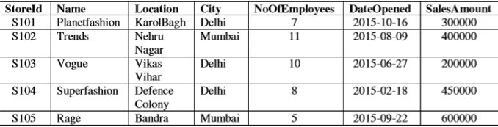  - SELECT NAME, CITY FROM STORE ORDER BY SALESAMOUNT DESC;  ii) SELECT NAME, SALESAMOUNT FROM STORE WHERE NAME LIKE ‘%R%’;  iii) SELECT LOCATION, DATEOPENED FROM STORE WHERE DATEOPENED  BETWEEN ‘2015-06-27’ AND ‘2015-10-10’;  iv) SELECT AVG(SALESAMOUNT),CITY FROM STORE GROUP BY CITY; |  | 1+2
  CNo | Cname | Sport
  C121 | Rohan Sharma | Cricket
  C055 | Sanmesh Seth | Football
  C100 | Anand Das | Chess
  CNo | City
  C100 | New Delhi
  C055 | Mumbai
27 | Write a function WORD() in Python to read the contents from a text file ‘Passage.txt’ and display 7 letter words not starting with a vowel..  OR  Write a function COUNTCHAR() in Python to read the contents from a text file ‘Prose.txt’ and display the character which appears the minimum times in the file. |  | 3
28 | - Write outputs of SQL queries i) to iv) based on the relations SALES and LOCATION given below:-  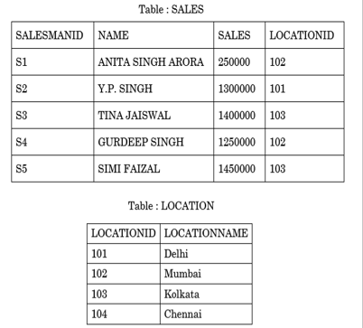  - SELECT LOCATIONID, AVG(SALES) FROM SALES GROUP BY LOCATIONID;  - SELECT S.NAME, L.LOCATIONNAME FROM SALES S , LOCATION L WHERE  S.LOCATIONID=L.LOCATIONID AND L.LOCATIONID=104;  - SELECT MAX(SALES) , MIN(SALES) FROM SALES;  - SELECT S.NAME, L.LOCATIONNAME FROM SALES S , LOCATION L WHERE  S.LOCATIONID=L.LOCATIONID AND S.SALES > 1400000;  - Write an SQL statement to delete the table Sales from the database. |  | 3
29 | Write a function PRIME(L) , where L is a list of elements passed as argument to the function. The function returns the sum of all prime numbers present in the list.  For example:  If L contains [3,14,28,31,5]  The output should be 39(3+5+31) |  | 3
30 | A list contains following record of an Employee E:  [Eno , Ename , Address, Salary]  Write the following user defined functions to perform given operations on a stack named Emp:  - Pus_ele(E) – To push objects containing Ename with length 7 to the stack  - Pop_ele() – To pop the elements from the stack and display them. Also display “Stack  Empty” where there are no elements in the stack.  For example:  If the list of Employee details are:  [‘M01’,’Mohan’,’Dubai’,4500]  [‘M02’,’Sushant’,’Sharjah’,7800]  [‘M03’,’Raghav’,’Dubai’,9670]  [‘M04’,’Simraan’,’Dubai’,3400]  [‘M05’,’Mohit’,’Sharjah’,7500]  The stack will contain  [‘M02’,’Sushant’,’Sharjah’,7800]  [‘M04’,’Simraan’,’Dubai’,3400]  OR  Write a function push(CItem) in Python where CItem is a dictionary containing the details of Car – {Cname : Model}  The function should push the names of movies into the stack M whose Model is greater than 2000. Also display the count of elements pushed into the stack.  For example:  Movie={“Toyota”:1998, “Nissan”:2000 , “Honda”:2021 , “Mercedes”:2022}  The stack should contain  Honda  Mercedes  The output should be :  The count of elements in the stack is 2 |  | 3
 | SECTION D
31 | Xcelencia Edu Services Ltd. is an educational organization. It is planning to set up its India campus at Hyderabad with its head office at Delhi. The Hyderabad campus has 4 main buildings - ADMIN, SCIENCE, BUSINESS and ARTS. You as a network expert have to suggest the best network related solutions for their problems raised in (i) to (iv), keeping in mind the distances between the buildings and other given parameters.  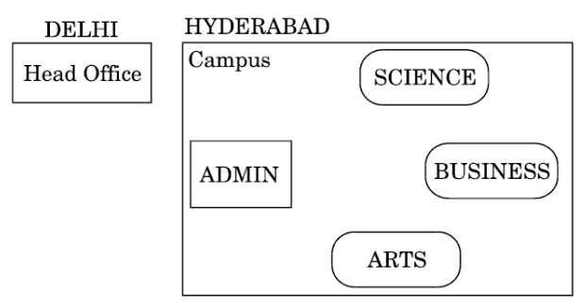  NO OF COMPUTERS IN EACH BLOCK  - Suggest the most appropriate location of the server inside the HYDERABAD campus (out of the 4 buildings), to get the best connectivity for maximum no. of computers. Justify your answer.  - Suggest and draw the cable layout to efficiently connect various buildings within the  HYDERABAD campus for connecting the computers.  - Which hardware device will you suggest to be procured by the company to be installed to  protect and control the internet uses within the campus ?  - Which of the following will you suggest to establish the online face-to-face communication  between the people in the Admin Office of HYDERABAD campus and DELHI Head Office ?  a. Email  b. Text Chat  c. Video Conferencing  d. Cable TV  v) Suggest the placement of the following devices with appropriate reasons  a. Hub / Switch |  | 5
  ADMIN TO SCIENCE | 65 M
  ADMIN TO BUSINESS | 100 M
  ADMIN TO ARTS | 60 M
  SCIENCE TO BUSINESS | 75 M
  SCIENCE TO ARTS | 60 M
  BUSINESS TO ARTS | 50 M
  DELHI HEAD OFFICE TO HYDERABAD CAMPUS | 1600 KM
  ADMIN | 100
  SCIENCE | 85
  BUSINESS | 40
  ARTS | 12
  DELHI HEAD OFFICE | 20
32 | - Write the output of the code given below:  def change():  l,l1,l2=[],[],[]  for i in ('AIMS'):  l.append(i)  for i in ('GOAL'):  l1.append(i)  for i in range(len(l1)):  l2.append(l[i]+l1[i])  l2.append(len(l)+len(l1))  print(l2)  - The code given below displays the following record in the table Employee:  Empno – integer  Name – string  Dept – string  Salary – integer  Write the following missing statements to complete the code:  import mysql.connector as mysql  def sql_data():  con1=mysql.connect(host="localhost",user="root", password="tiger", database="emplo")  mycursor=_______________ #Statement 1  print("Employees who belong to Sales department : ")  ____________________ #Statement 2  data=__________________ #Statement 3  for i in data:  print(i)  print()  Statement 1 – to form the cursor object  Statement 2 – to execute the query that extracts records of those Employees who belong to Sales department  Statement 3- to read the complete result of the query (records whose Employees belong to Sales department) into the object named data, from the table emp in the database.  OR  - Predict the output of the code given below:  str1="ORACLE-19C"  str2=""  I=0  while I<len(str1):  if str1[I]>="A" and str1[I]<="R":  str2=str2+str1[I-1]  elif str1[I]>="0" and str1[I]<="9":  str2=str2+str1[I+1]  else:  str2=str2+"*"  I=I+1  print(str2)  - The code given below inserts the following record in the table Employee:  Empno – integer  Name – string  Dept – string  Salary – integer  Write the following missing statements to complete the code:  import mysql.connector as mysql  def sql_data():  con1=mysql.connect(host="localhost",user="root", password="tiger", database="emplo")  mycursor=_______________ #Statement 1  Empno=int(input(“Enter Empno”))  Name=input(“Enter name”)  Dept = input(“Enter dept”)  Salary=int(input(“Enter salary”))  Q=”insert into emp values({},’{}’,’{}’,{})”.format(Empno,Name,Dept,Salary)  ____________________ #Statement 2  ____________________ #Statement 3  print(“Data added successfully”)  Statement 1 – to form the cursor object  Statement 2 – to execute the command that inserts the record in the table Emp.  Statement 3- to add the record permanently in the database. |  | 2+3
33 | Expand CSV  Write a program in python that defines and calls the following user defined functions:  - ADD() – To accept and add data of a book to a CSV file “Bookdetail.csv”. Each record consists of a list of field elements as bookid , bname , genre , cost.  - COUNT() – To count no of books whose cost is greater than 200  OR  What is the function of next() in a CSV file?  Write a program in python that defines and calls the following user defined functions:  - ADD() - To accept and add data of furniture to a CSV file “Furnit.csv”. Each record consists of a list of field elements as fid , fname , fcost  - SEARCH() – To display details of furniture whose fname is ‘Chair’ |  | 5
 | SECTION E
34 | Consider the table StudAdmin given below:  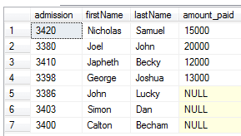  Based on the data given above answer the following questions:-  - Identify the most appropriate column, which can be considered as Primary key.  - If three columns are added and five rows are deleted from the table result, what will be the new degree and cardinality of the above table?  - Write the statements to:  a. Insert the following record into the table : admission - 5000 , firstname - Sam  b. Increase the amount_paid of the student whose firstname begins with ‘J’ by 20%.  OR (Option for part iii only)  iii) Write the statements to:  a. Delete the record of student whose amount_paid is less than 20000  b. Add a column Department in the table with datatype as varchar with 30 characters |  | 4
35 | Asim has written a code and created a binary file Record.dat with employeeid, ename and salary. The file contains 10 records. He now has to update a record based on the employee name entered by the user and update the salary. The updated record is then to be written in the file Temp.dat. The records which are not to be updated also have to be written to the file Temp.dat. If the employee id is not found, an appropriate message should to be displayed. As a Python expert, help him to complete the following code based on the requirement given above:  import _______ #Statement 1  def update_data():  rec={}  fin=open("Record.dat","rb")  fout=open("_____________") #Statement 2  found=False  ena=input("Enter employee name to update their salary :: "))  while True:  try:  rec=______________ #Statement 3  if rec["Ename"]==ena:  found=True  rec["Salary"]=int(input("Enter new salary :: "))  pickle.____________ #Statement 4  else:  pickle.dump(rec,fout)  except:  break  if found==True:  print("The salary of employee name ",ena," has been updated.")  else:  print("No employee with such id is not found")  fin.close()  fout.close()  - Which module should be imported in the program? (Statement 1)  - Write the correct statement required to open a temporary file named Temp.dat. (Statement 2)  - Which statement should Asim fill in Statement 3 to read the data from the binary file, Record.dat  - Write a statement to write the updated data in the file Temp.dat (Statement 4) |  | 4

***

